**Bangladesh Army University of Engineering &Technology   
(BAUET)**



**Department of Computer Science and Engineering (CSE)**

Course Title : Software Development for Web Apps Sessional

Course Code : CSE-4106

**Project Name: Green Life**

**Submitted to:**

Md Omar Faruq

Lecturer,Dept of CSE

Mst. Irin Sultana

Lecturer,Dept of CSE

BAUET

**Submitted by:**

Name:MD Tanvir Ahmed

Id: 19104012

Name: Naima Mannan Mumu

Id: 19104042

Batch:9th

Year: 4th

**Project title: Green Life**

**1. Explanation of some existing system:**

This Project Aims To Give A People Healthy Lifestyle Without Medicine.People Can Give Treatment By Natural Food & Workout .They Can Lead A Healthy Life -Style By The Help Of Our Online Trainer.They Can Also Hire Online Trainer By Our Website.

Additionally, for many Fitness sites, the focus has shifted away from Anti Hospitality .Some existing websites are,

* Thenx
* Exercise.Com
* Athlean-X
* Gym-Life
* Australian Fitness Academy.
* Mirror
* Yoga & Fitness

**2. Scope of our works:**

Our website will have all updates information about Diseases& It’s Treatment & Workout. There will be different section for Anti-Hospitality. Users Can Hire Online Trainer.There will be a login section , where user can sign up for an account.

**3. Methodology:**

Step 1: After entering in the website you will find several button. Each button is for different purposes

Step 2: For login , you need to press login icon, and give you informaion to log in.

Step 3:If you do not have an account go to the sign up page , give you needed information and sign up

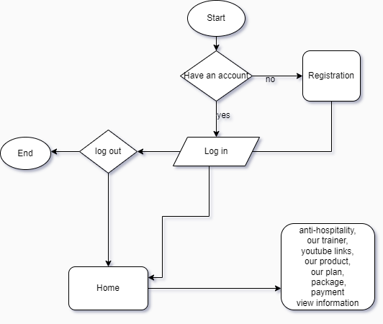

Figure: Flowchart of Green Life

**4. Requirements of your proposed models for the development:**

1. Web Developer
2. Software:

* Xampp
* VS Code

1. Personal Computer
2. Internet
3. Programming Language:

* HTML
* CSS
* Java Script
* PHP

1. **Discussion:**

**5.1 Advantage of Our Website :**

Our website will provide features which are totally free . Interface of the website will be user friendly.

**5.2 Disadvantages of Our Website:**

It Requires Continuous Time Investment. ..